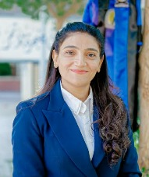
SHERINE FAWZY KAMEL REZK
- University Name: south valley university
Faculty of science and education
- Major : science
- Last year grade: very good
- Certification
- Intel training programmer
From 3/11/2012n to 18/11/2012
- Intensive course in teaching the science in English
(physics,chemistry,Geology and Biology using the computer technology From 21/12/2013 to 30/ 1/2014 With general grade :Excellent

- Professional Diploma in Educational Technology – Very Good Grade 20/8/2022
- ICT South valley University 10/2022
- Special Diploma in Education, Major: Science Curriculum and Teaching Methods – Grade: Very Good16/ 10 /2023

- English proficiency test (TOEFL) SCORE OF 92 IN 15/10/2025

- Master’s Degree in Science Curriculum and Instruction

ADRESS:
Nag Hammadi- Qena
T:01024658648
Email
Sherineuwk @ gmail.com
Personal information
Gendar: Femal
Data of birth
7-11-78
Marital statues
Married
Language
Arabic:: mother tongue
English : very good
French: good
Skills
• Problem solving
• Adaptation
• Collaboration

